Title: Economics, Brexit, and Nationalism in the EU
Subject: EEP 18

1. The rise of nationalism  2. How to explain? Colantone stanig  3. Tech change an globalization shape polictics  A. Globalization: The China shock  B. Globalization and support for Brexit | Revival of nationalism in Western democracies:  - 2016 Trump election (America first)  - 2016 Brexit (Britain first)  - Rising support for nationalist / radical right parties from then 90s  How to explain this? Two ways:  B. Economic factors, ex. economi insecurity = threat from globalization?  A. Cultural factors:  Racism, illiteracy + society is growing fast (LGBT, new morality, etc…). Some ppl do not like these new values, radical right the guardian of traditional values  Globalization and technological progress generate distributional consequences, i.e., winners and losers, and this leads to political repercussions.  Globalization shock => I lose my job (maybe I also change attitude, opinions)=> I support UKIP party = vote for brexit  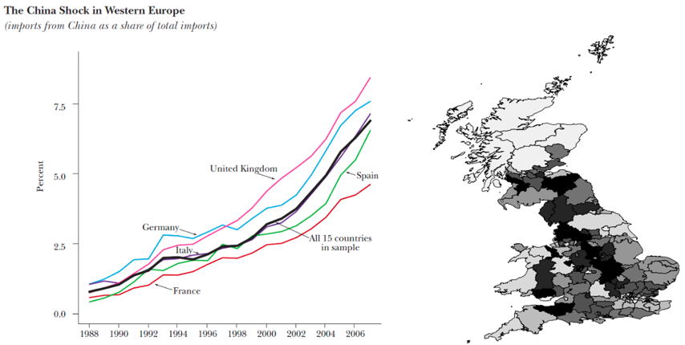  Regression (districts):  A. Brexit yes - % of non UK born => flat! It’s not about immigrants! You thought this was the reason but was not  B. Brexit yes – import shock => Positive and significant!  Robustness  ◦ Findings confirmed with individual-level vote choices.  ◦ Effect reaches beyond directly exposed manufacturing workers, i.e. ‘sociotropic’ response.  Interpretation  Globalization imposes higher costs in some areas => those fall behind in GDP/capita. Three non-mutually exclusive mechanisms:  1. Vote against the incumbent: political elites and business establishment  2. Vote against international integration, to take-back-control  3. Vote against immigration (it’s about perception, not actual %), linked to Chinese shock due to:  - scarcity of job opportunities;  - congestion on welfare services;  - scapegoating.  Policy considerations  Globalization is not politically sustainable in the LR if we do not address inequality generated by it

